Altti Väätäinen 5.3.2023

Documentation for the Advanced Web Applications project work

I chose to use JavaScript as the coding language for the app, because it felt the most comfortable language to do the project work. I did the implementation of the backend with Node.js and Express. I chose to use MongoDB for the database, because I’ve used it the most on all my previous courses and it is simple to use. Authentication has been done using JWT when the user logs in. To make the app responsive, I have used Materialize UI and it’s components. Those components also make the app more appealing to eye.

I have implemented the basic features that let the user register, login and post new code snippets. Non-authenticated users can see all the content but cannot post or comment items. Data is saved to a MongoDB database. The code is also documented. These basic features give 25 points in total. And additionally, I have utilized frontside framework, which is worth 5points. So I’m aiming for 30 points total.

|  |  |
| --- | --- |
| **Feature** | **Max points** |
| Basic features | 25 |
| Utilization of a frontside framework, such as React, but you can also use Angular, Vue or some other | 5 |

**Installation guidelines**

This project was done with node version 19.6.0, NOT 12.0.0

Get the source code from this project and copy it to a folder on your computer. Then install the dependencies by running the next script in the root folder terminal:

npm install

The dependencies in the “client” folder should look like this:  
[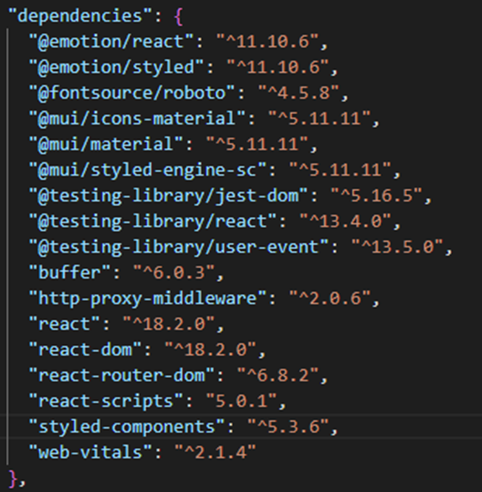](https://user-images.githubusercontent.com/79470113/222975374-3b94aaae-ed0e-484a-9479-5d378a929da0.png)

The dependencies in the "server" folder should look like this:

[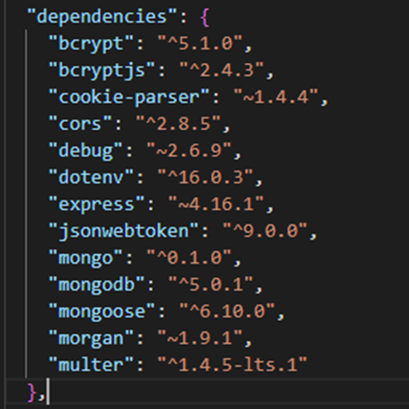](https://user-images.githubusercontent.com/79470113/222975540-0de64e79-65b8-4c77-a6ef-dc6618b86f05.png)

MongoDB database can be accessed with this connection: “mongodb://127.0.0.1:27017/testdb”

After this, go to the root folder and run the following command in the terminal to start the server:

SET NODE_ENV=production& npm run dev:server

Then open “client” folder’s terminal and run the following command to start the frontside:

npm start